Application Form

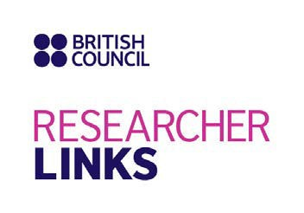

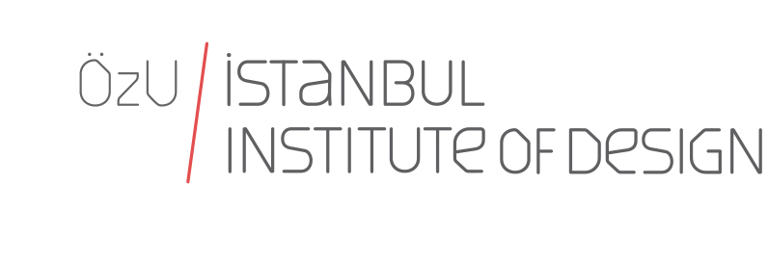
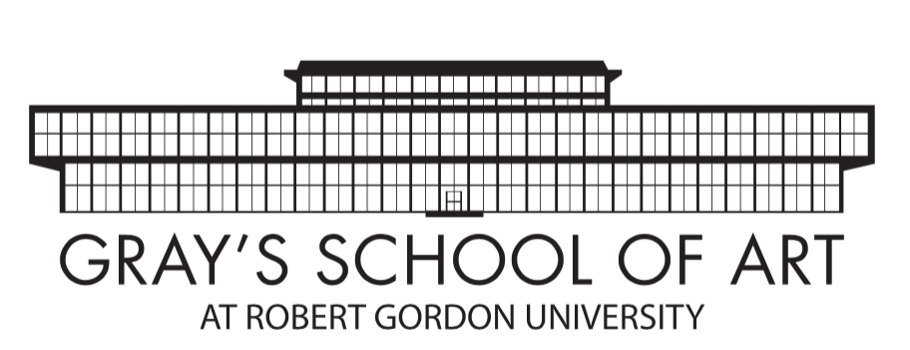

Workshop Title: Rethinking food: The creativity of entrepreneurship
UK coordinator: Professor Anne Douglas, Robert Gordon University
Partner Country coordinator: Professor Alpay Er, Ozyegin University
Discipline: Design
Dates and venue: 3-6 October, Istanbul

The programme, ‘British Council Researcher Links’ provides opportunities for early career researchers from the UK and internationally to interact, learn from each other and explore opportunities for building long-lasting research collaborations.

As part of this programme, we are now recruiting early career researchers to participate in the above workshop.

The workshop will provide a unique opportunity for sharing research expertise and networking. During the workshops early career researchers will have the opportunity to present their research in the form of a poster/short oral presentation) and discuss this with established researchers from the UK and partner countries. There will be a focus on building up links for future collaborations and participants selected on the basis of their research potential and ability to build longer term links.

The British Council and TUBITAK will cover the costs related to the participation to the workshop, including: travel (both international and local), accommodation and meals. Costs for the visa will be covered; however participants will be responsible for making all the necessary arrangements. Although this cost will not be covered by the British Council, participants are encouraged to purchase an adequate travel and medical insurance. The British Council accepts no responsibility for any problems which may occur when the participants are in-country.

Application and Deadline:
The full application below must be completed and submitted by the 27 July 2017 to: n.gulari@rgu.ac.uk
Eligibility Criteria:
- Applications must be submitted using the Researcher Links application form
- Application must be submitted before the above deadline
- Participants must be Early Career Researchers: Early Career Researchers are defined as holding a PhD (or having equivalent research experience) and having up to 10 years post-PhD research experience. They are equivalent to the ‘Recognised Researcher’ and sometimes ‘Experienced Researcher’ categories in the EU framework for researchers’ careers. http://ec.europa.eu/euraxess/pdf/research_policies/Towards_a_European_Framework_for_ Research_Careers_final.pdf .
- Participants must have a research or academic position (a permanent post, research contract, or fellowship etc) at a recognised research institution either in the UK or in Turkey.
- Participants in the final stages of their PhD ( or equivalent) are welcome to apply
- Please note that participants are expected to attend all sessions of the workshop.

Quality Assessment
- Experience and relevance of the applicant’s research area to the workshop
- Motivation and contribution to the aims of the workshop
- Description of the long term impact expected through the participation in the workshop
- Ability to disseminate workshop’s outcomes

Selection Procedure:
  - Eligibility check
  - Quality assessment

Notification of results:
Applicants will be notified by email 2 months prior to the workshop.

Equal Opportunities
Equal opportunities and diversity are at the heart of the British Council’s cultural relations ambitions. While recognising that some research fields are dominated by one particular gender, co-ordinators are encouraged to work towards an equal gender balance, promote diversity. They must not exclude applicants on the basis of ethnicity, gender, religious belief, sexual orientation, or disability. Participants’ selection undertaken by workshop organisers must not contravene this policy. Extra support to enable participation of Early Career Researchers with special needs will be given.
Workshop Application Form

1. Applicant
Name and title
Gender (for statistical purposes. This will not affect choice of participants)
Position and institution
Postal address
Email
Phone number
Brief CV (academic career, publications, markers of esteem, and any other relevant information) – no more than ½ page of A4

2. Abstract - Please give a summary of your area of research

3. Please describe your motivation for attending the workshop and how the workshop matches your professional development needs

4. Please describe the expected impact of your participation on your personal and professional development, including your ability to work internationally

5. Please indicate how you will disseminate the outcomes of the workshops and the new knowledge/skills you have acquired

6. Workshops will take place in English as standard. Please indicate your ability to work and communicate in English (Note, translators may be provided if necessary)
Native speaker |  | Good
Excellent |  | Need support

7. Please use this space to give any additional information that you feel is relevant for the application.

